Wednesday January 17th, 2024

Cycles - Women

* <https://www.ncbi.nlm.nih.gov/books/NBK500020/>
* Based on a 28-30 day cycle

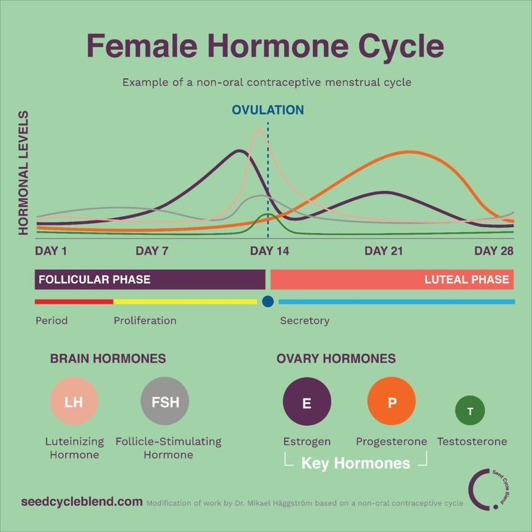

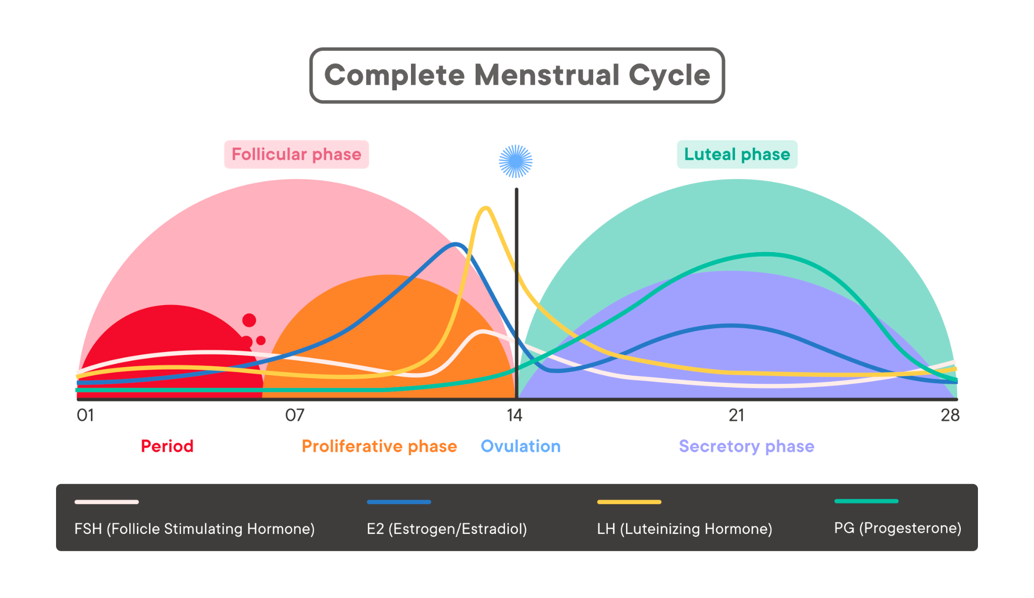

Cycles - Men

* <https://www.hollandandbarrett.com/the-health-hub/conditions/mens-health/men-master-your-hormones/#:~:text=The%20male%20hormone%20cycle&text=Men%20actually%20experience%20a%20full,affect%20mood%2C%20attitudes%20and%20behaviour.&text=Testosterone%20in%20men%20reaches%20its,after%209am%20throughout%20the%20day>.
  + Links how/when to accomplish tasks in association with the 24 hour male hormonal cycle
  + Explains male menopause (andropause)
* <https://drzenovia.com/blogs/skin-journal/male-hormonal-cycles-hormonal-dermatology>
  + Links male hormonal cycles to skin health
* <https://www.sciencedirect.com/science/article/pii/S0031938411003611>
  + Testosterone can actually peak based on seasons
  + Little research has gone into this theory
  + Hypothesised that it's the same for both men and women

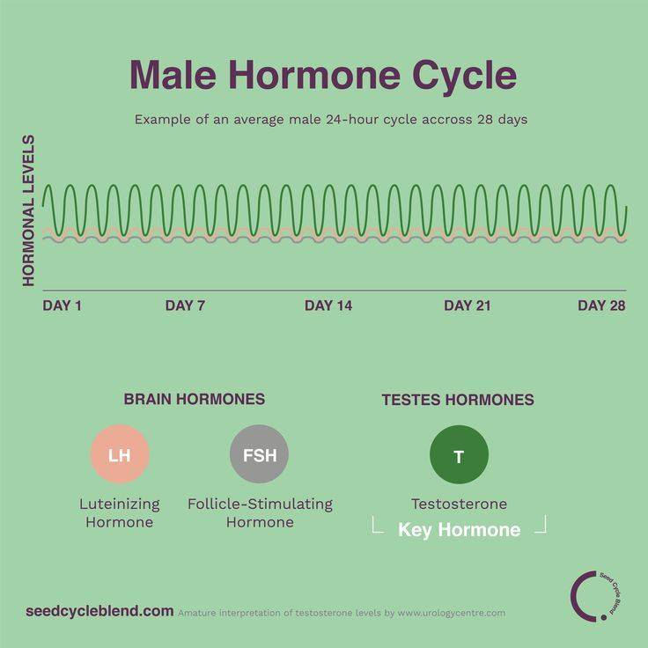

Solid Pods

* <https://solidproject.org/about>
* Solid is a specification that lets people store their data securely in decentralized data stores called Pods. Pods are like secure personal web servers for your data.
* Any kind of information can be stored in a Solid Pod.
* You control access to the data in your Pod. You decide what data to share and with whom (be it individuals, organizations, and/or applications). Furthermore, you can revoke access at any time.
* To store and access data in your Pod, applications use standard, open, and interoperable data formats and protocols.